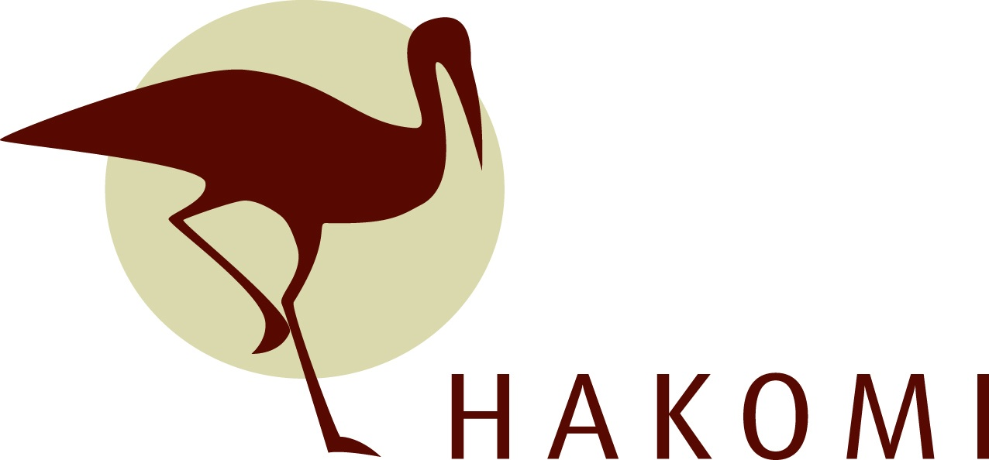
In-Person in Edmonton, A.B.
A Somatic Approach to Working with Trauma, a Level II Hakomi Workshop

Friday & Saturday,
November 10 & 11, 2023
“After trauma the world is experienced with a different nervous system. The survivor’s energy now becomes focused on suppressing inner chaos, at the expense of spontaneous involvement in their life.” ~ Bessel van der Kolk, The Body Keeps the Score: Brain, Mind and Body in the Healing of Trauma.

Learning how the body (somatically) experiences trauma and how to utilize principles in practice, and mindfulness skills to help client’s somatically reorganize towards a more felt sense of safety and well being following traumatic experiences is the focus of this workshop.

Learning how to address the somatic implications of trauma is recognized as an important part of working with those who have been traumatized and is considered by many to be the most effective way to help clients in recovery and in reintegration into their lives.

Workshop Objectives
Through lecture, demo, and practice exercises, this workshop will introduce you to effective interventions and skills you can immediately use with clients:

- The Hakomi Principles as they relate to working somatically with trauma,
- Understanding how to recognize and utilize somatic cues to restore physical
and emotional regulation states from dysregulated states,
- Historical core beliefs that influence trauma recovery,
- Working through faculty neuroceptions and the embodied threat responses those
affected by trauma often experience,
- Ethical practice in physicalizing techniques for working with trauma responses,
- Self-caring strategies for therapists working with trauma.
Taught by Pamela Thompson, Registered Psychologist and Certified Hakomi Therapist and Trainer. Pamela has been in private practice for over 20 years; and has been an instructor at graduate level studies for those entering the field of psychology. She has provided years of supervision to practicum students as well as provisional psychologists. Pamela has many years of working within the Hakomi community and advancing her skills with the Hakomi method and using this method with diverse populations.

HAKOMI INSTITUTE OF EDMONTON
e-mail: website:
hakomi.edmonton@gmail.com hakomiedmonton.ca
Workshop Registration Form

Please return this form with a cheque or
INTERAC e-Transfer for your full payment to:

Hakomi Institute of Edmonton
#204B, 10544-106 Street, Edmonton, T5H 2X6
hakomi.edmonton@gmail.com

Name
Street Address
City |  | Postal Code
Home/Cell Phone |  | Work Phone
Email Address
Please list any dietary restrictions for snacks.
How did you hear about this workshop?

May we add you to our e-mail list?

Please note advanced cleaning and distancing protocols may be in place. All reasonable attempts will be made to host this workshop in person. It will however, be moved online should public health restrictions or concerns be in place.

TIMES | INVESTMENT | LOCATION
Friday & Saturday,  November 10 & 11, 2023  9:00am – 4:30pm  Lunch 12:30-2:00 | Early Bird Price - before October 6: $367.50 / $315* (incl. GST)  $350 / $300* + GST (standard / *BIPOC, full-time student, non-profit)  Regular Price: $420 / $367.50* (incl. GST)  $400 / $350* + GST (standard / *BIPOC, full-time student, non-profit) | TBA  Edmonton, AB

