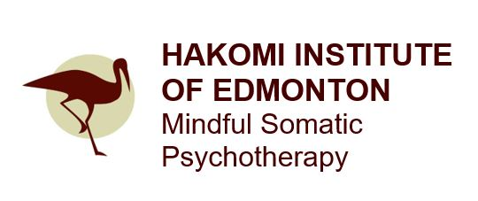
R-CS Five Day Intensive Workshop
Registration Form

Please return this form and a cheque/email money transfer for your full payment to:
#204B, 10544 – 106 Street NE, Edmonton, AB T5H 2X6
or Hakomi.Edmonton@gmail.com

Please make cheques payable to Hakomi Institute of Edmonton or etransfers to Hakomi.Edmonton@gmail.com Registration is also available online
at www.hakomiedmonton.ca

Name
Street Address
City |  | Postal Code
Home/Cell Phone |  | Work Phone
Email Address
How did you hear about this workshop?

May we add you to our e-mail list (please circle)? YES No

The Re-Creation of the Self (R-CS) Five Day Intensive Training
Wednesday to Sunday, October 17 & 21, 2018 Edmonton, AB
TIMES | TUITION | LOCATION
Wednesday, October 17, 2018  2:00 pm – 5:00 pm  Thursday to Saturday,  October 18-20, 2018  9:00am – 5:00 pm  Sunday, October 21, 2018  9:00 am – 1:00 pm | Investment:  $650 by June 30th, $750 by Sept 03rd, $850 thereafter  $650, if you’ve previously taken R-CS Intensive Training | TBA  Edmonton, AB

Hakomi Institute of Edmonton Organizer: Petros Efstathiou, 780-619-4412
Hakomi.Edmonton@gmail.com

